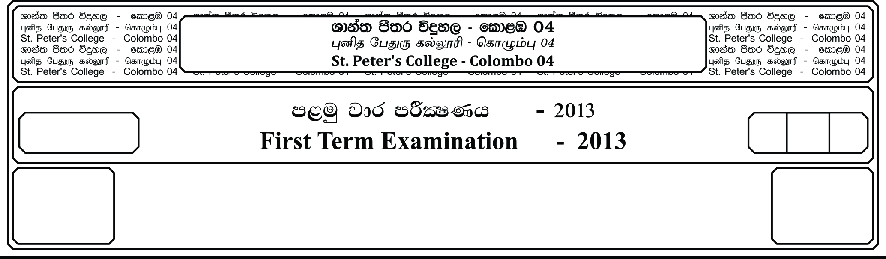

13 fY%aKsh

GRADE 13

E

meh 01

01 Hour

I

**fojk jdr mÍCIKh - 2022**

**Second Term Examination - 2022**

idudkH bx.%Sis

**GENERAL ENGLISH**

**Part I**

**01.** **Fill the blanks with the following suitable prepositions.**

It is not possible **1.** _________________ divide man **2.** _________________ two different compartments, as physical and spiritual. The man who does not have sufficient food **3.** _________________ eat, or a suitable house to live in, has no time to think of spiritual matters. So as the man who has all physical comforts but is tormented **4.** _________________ mind **5.** _________________ his problems. Both suffer, each with his own set **6.** _________________ problems.

The aim of education should be to bring **7.** _________________ a society of human beings who are happy physically as well as psychologically. Education should be aimed **8.** _________________ developing all aspects **9.** _________________ human life. True education will simultaneously bring **10.** _________________ both advancement of knowledge and advancement of character.

**The following prepositions can be used more than once**

Of , into , to , about , at , in with

**02. Fill the blanks with appropriate verbs given in brackets.**

Tourism **1.** _________________ **(be)** a very profitable industry for many countries in the world today. It **2.** _________________ **(generate)** income through the consumption of goods and services by tourists, infact tourism **3.** _________________ **(been)** identified as one of the world’s largest industries and **4.** _________________ **(be)** more and more **5.** _________________ **(develop)** world wide. The industry **6.** _________________ **(has)** grown enormously over the last 50 years, and there **7.** _________________ **(be)** few places which are unaffected by tourism. Tourism also **8.** _________________ **(bring)** popularity and fame to the country. Tourism **9.** _________________ **(become)** a popular global leisure activity. Another benefit of Tourism is that **10.** _________________ **(travel)** develops an understanding of other cultures.

**(10 Marks)**

**03. Write the correct form of the word in the blank.**

1. I really admire Peter’s _______________ **(creative)**

2. Nelani’s new dress looks absolutely _______________ **(love)** on her.

3. Children between the ages of 2 and 4 are usually extremely _______________ **(life)**

4. I didn’t steal her money but I simply could’t _______________ **(proof)** it.

5. What I like most about Nalin is his _______________ **(friend)**

6. Some wild animals can be really _______________ **(danger)**

7. Breaking my leg was a very _______________ **(pain)** experience.

8. Being _______________ **(health)** and _______________ **(wealth)** is much better than being

_______________ **(poverty)** and _______________ **(illness)**

9. Johan’s reaction on what I said made me really _______________ **(anger)**.

10. This drink is much too _______________ **(strength)** for me. **(05 Marks)**

**04. Underline the correct answer.**

1. English Grammar can be very (confusing , confused)

2. I am very _______________ in the cultures of India. (interested , interesting)

3. I was _______________ when I first heard about Corona pandemic. (shocking , shocked)

4. Mr. Premasiri is such dull speaker. His classes are always (bored , boring).

5. Your report card is quite _______________ son. You need to study harder! (disappointed , disappointing)

6. I had such a _______________ day at work, I went straight to bed. (exhausted , exhausting)

7. The way that light shines produces very _______________ effect. (pleased , pleasing)

8. Our whole school was _______________ by our classmate’s death. (saddened , saddening)

9. The story wa so _______________. None of us could guess what would happen. (intrigued , intriguing)

10. Andrew was really _______________ when the teacher caught him with cheat notes. (embarrassed, embarrassing) **(05 Marks)**

**05. Select the correct conjunctions and rewrite the sentences.**

**[Unless , but , because , yet , despite]**

1. I am very hungry. The fridge is empty.

2. Everybody likes him. He has faults.

3. You don’t need to go. You want to

4. She usually eats at home. She likes cooking.

5. We haven’t finished. Eating the watermelon. **(05 Marks)**

**06. Complete the paragraph using the modals below.**

**[could , have to , must , ought to , might]**

I seem to spend most of my time studying. I am sure of this _______________ be very unhealthy. May be I _______________ try to change something in my lifestyle. You want to start riding your bike to school. My mother suggested. You _______________ ride very well when you were younger. Of course, I will _______________ buy you a new bike.

**(05 Marks)**

**07. Read paragraph and answer all the questions given below.**

What will happen to the earth in the future? Scients believe that over the next 10,000 million years earthquakes and volcanoes will get rarer. The earth will become flatter, with no high

mountains and shallow oceans will cover most of the planet.

The sun will run short of the hydrogen if uses for fuel and become much larger than it is now. This will heat up the earth, evaporating water from the seas and the oceans will get dry. Eventually the sun will cool down, leaving the earth as a dead frozen planet.

Man might make our planet uninhabitable long before any of this happens. We may increase the carbon dioxide in the atmosphere so that it forms a barrier that lefts heat in but doesn’t let it out. Carbon dioxide is produced by burning wood, coal and petrol and is absorbed by forests. So we must avoid burning too much fuel and cutting down too many tress. Another danger to our earth is caused by the release of chemicals known as CFCs which are used in refrigerators and aerosol sprays. These rise into the atmosphere and damage the Ozone layer, which protects us from harmful radiation from the sun. Fortunately, a lot of people with very useful ideas recognize those dangers and are working to protect our planet. Our earth is a delicate and beautiful planet, so we must take good care of it. It is all we have.

**A. Say which of the following statements are true or false.**

1. In the future there won’t be any water in the oceans.

2. The surface of the earth will be just like it is now.

3. In the end, the temperature of the earth will be extreamly high.

4. When some natural disasters occur man will no longer exist.

**(04 Marks)**

**B. Complete the sentences according to the text.**

1. According to scientists, it will be very difficult _____________________________________

2. Burning too much fuel and cutting down too many tress. _____________________________

3. The Ozone layer _____________________________________________________________

**(06 Marks)**

**Write a paragraph beginning with the following sentence.**

Education is the only critical factor to the development of a country

**(10 Marks)**